OS Migration RHEL 7 to RHEL 8 SOP

- RHEL 7 TO RHEL 8 OS migration steps.

- Take snapshot or Backup of OS VM server or physical server.

- Take current date sanity file on your desktop from /opt/scripts

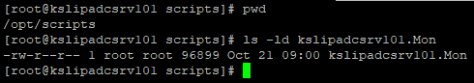

- Umount the non-OS mount point from servers and # non-OS mount point in /etc/fstab.

- EXP: - umount /else
- EXP:- vi /etc/fstab
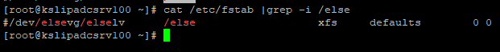

- Check the server running on which OS level.

Command: - cat /etc/redhat-release

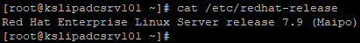

- Check the server is running on latest kernel or not. If yes, than start the upgrade activity and if server is not running on latest kernel of 7.9 than patch the server to latest kernel.

Command: - uname -r

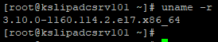

- Copy leapp RPM packages and data file from below mentioned location to server.

- Create new directory in /tmp
Command: – mkdir /tmp/rhel
- Copy data from sources to destination.
Source location: - Z:\AIX-Team\2021-2022\UNIX\software\RHEL 7 to 8
Destination location - /tmp/rhel

- Enable or verify local repository for RHEL 7.9.

Command: – vi /etc/yum.repos.d/local-rhel7.repo
[LocalRepo]
name=LocalRepo
enabled=1
gpgcheck=0
baseurl= http://10.6.4.75:8443/repositor/rhel7.9/rhel-7-server-rpms

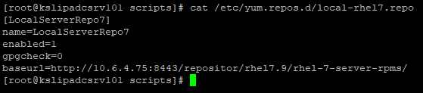

- Install the required leapp packages for the upgrade.
- Change current directory to /tmp/rhel directory for rpm installation
Command: - cd /tmp/rhel
- Install below mentioned RHEL leapp RPM.

Command: - yum install *.rpm
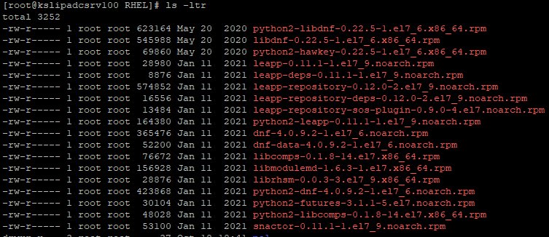
- Extract data file form /tmp/rhel/ to /etc/leapp/files

Command: - tar -xzf /root/temp/migration/RHEL7to8/leapp-data15.tar.gz -C /etc/leapp/files && rm leapp-data15.tar.gz

- Configure RHEL 8 repo file (leapp_upgrade_repositories.repo) to /etc/leapp/files.

Command: - vi /etc/leapp/files/leapp_upgrade_repositories.repo

[BaseOS]
name=rhel-8-for-x86_64-baseos-rpms
baseurl=http://10.6.4.75:8443/repositor/rhel8.10/rhel-8-for-x86_64-baseos-rpms

[AppStream]
name=rhel-8-for-x86_64-appstream-rpms
baseurl=http://10.6.4.75:8443/repositor/rhel8.10/rhel-8-for-x86_64-appstream-rpms

- Disable below mentioned pre-requisite for OS migration.
- Disable proxy if enabled
- Remove noexec from all mount point from /etc/fstab.
EXP: - /home /tmp /var
Command: - mount -o remount /home
Command: - mount -o remount /tmp
Command: - mount -o remount /var

- Create backup of local repository /etc/yum.repos.d/
EXP: - mv local-rhel7.repo local-rhel7.repo_backup

- Enable below mentioned pre-requisite for OS migration.

- Edit /etc/ssh/sshd_config and configure PermitRootLogin no to PermitRootLogin yes
Command: - vi /etc/ssh/sshd_config
Edit:- PermitRootLogin yes
- Increase ulimit of root user for temporary propose

Command: - ulimit -n 16384

- Run the preupgrade command to perform the assessment of the system

Command: - leapp preupgrade --no-rhsm --enablerepo BaseOS --enablerepo AppStream

Incase of any leap package error
yum remove zabbix-agent-4.2.3-2.el7.x86_64
yum remove leapp-upgrade-el7toel8
yum remove leapp-upgrade-el7toel8-deps-0.20.0-9.el7_9.noarch
yum install leapp-repository-0.12.0-2.el7_9.noarch.rpm
yum install leapp*

rmmod floppy pata_acpi ----- if required
leapp answer --section remove_pam_pkcs11_module_check.confirm=True ----- if required

- Check /var/log/leapp/leapp-report.txt file for error. If found any error [Risk Factor: high (error)] solve error and then run preupgrade if not found any error the go to next step (15).

Command: - cat /var/log/leapp/leapp-report.txt

- Run the upgrade command to perform the upgrade of the system

Command: - leapp upgrade --no-rhsm --enablerepo BaseOS --enablerepo AppStream

rmmod floppy pata_acpi

- After completing, the leapp upgrade command it’s asked for reboot. Reboot the system to upgrade the system RHEL 8.10.
Command: - reboot
- Reboot
To complete the installation; you need to reboot the system. After rebooting, depending on how many packages were being upgraded, it could take some time to complete. If everything goes as expected, the system will reboot to Red Hat Enterprise Linux 8.10, and you can start checking that the system works properly or not.
- Verify the system

- To make sure that the system was upgraded to a RHEL 8 OS.
Command: - cat /etc/redhat-release
- Add noexec on below mentioned mount points in /etc/fstab file.
EXP: - /var /tmp /home
Command: - mount -o remount /home
Command: - mount -o remount /tmp
Command: - mount -o remount /var
- Install required RPMS with removed while upgrading the system.
EXP: - yum install nmon
- Remove the hash from /etc/fstab and Mount application mount point.
EXP: - mount /else /app /data
- Verify sanity that file which we have taken before upgrading the system.

- Everything working as expected then realise server to application team

THE END FOR RHEL 7 TO RHEL 8

